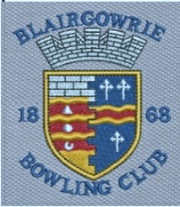

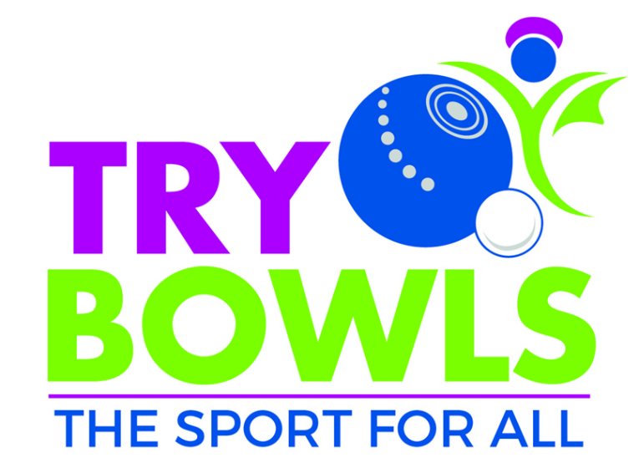
Lochy Terrace, Blairgowrie PH16 6HY 01250 873661

Try Bowls Day

Sunday 4th May 10-1pm

Looking for a new challenge?
Come along and try bowling!

All equipment provided,
please wear trainers
All ages welcome
Children under 12 accompanied please

